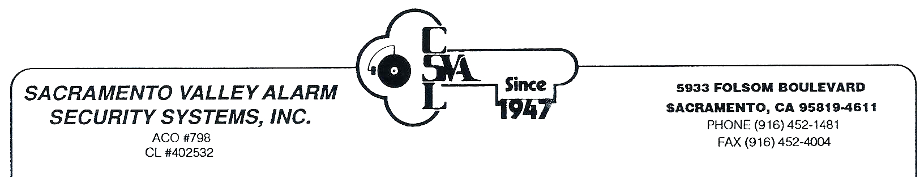
Residential Central Station Emergency Notification List
In order to assist us in the handling of the activity on your account, please provide us with the following information and return this form to our office.
_______________________________________________________________________ ________________________ Name of Account Account #
________________________________________________ ___________________________ __________________ Address of Alarm System City State/Zip
_______________________ _________________________________ ____________________________________ Premise Phone # Nearest Cross Street Email Address
In case of an emergency (i.e. burglary, fire and/or panic alarms) please list the individuals in the order in which they are to be notified by our Central Station. Unless otherwise specified, the premise will be notified first.
 | Name | Phone # | Cell # | Work #
1
2
3
4
5

If there are any other specific instructions in which you would like our Central Station to follow in terms of emergency contacts, please describe below.
_______________________________________________________________________________________________________________________________________________________________________________________________________________________________________
Please notify the Central Station at (916) 452-4651 if there should be any changes to the above information.

__________________________________________________________________ __________________________ Signature Date

